Effective Möbius Topology via Multi-Frequency Phase Coupling in Graphene–hBN Serpentine Waveguides
Chur Chin
Department of Family Medicine, Dong-eui Medical Center, Busan 47227, Republic of Korea
Electronic mail: tpotaoai@gmail.com
ABSTRACT
We demonstrate that a Möbius-like topological phase state can be realized in graphene–hexagonal boron nitride (hBN) serpentine waveguides without physical strip fabrication, through controlled multi-frequency wave coupling across the infrared (IR), radio-frequency (RF), and ultraviolet (UV) spectral domains. The effective Möbius condition—a closed-loop π phase inversion—is governed by the total accumulated phase Δϕtotal = kIR L + αARF + βIUV, where kIR is the graphene plasmon wavevector, L is the serpentine path length, ARF is the RF amplitude acting as a global phase modulator, and IUV is the UV intensity that triggers abrupt carrier-density switching. RF irradiation provides continuous global phase coherence across the entire structure, while UV pulses induce discontinuous, nonlinear state transitions via carrier excitation in graphene. We further show that this multi-frequency Möbius state implements a topological XOR logic operation through wave interference, without conventional nonlinear circuit elements. Phase-state diagrams and coupling heatmaps identify controllable Möbius windows as a function of RF and UV parameters. These results establish a new paradigm of frequency-multiplexed topological phase computing compatible with neuromorphic architectures.
Keywords: Möbius topology; graphene plasmonics; hBN waveguide; multi-frequency coupling; topological phase; XOR logic; neuromorphic computing; UV carrier switching; RF phase synchronization
I. INTRODUCTION
Möbius strips are archetypal objects of topological interest: a single-surface structure in which a closed traverse produces a phase inversion of π. In photonics and condensed-matter physics, Möbius-like topological states have attracted growing attention because they protect certain quantum and classical wave properties against perturbation (1,8). Physical fabrication of Möbius structures at the nanoscale, however, remains extremely challenging. Here we propose and analyze a fundamentally different strategy: realizing an effective Möbius condition through phase engineering in a planar graphene–hBN serpentine waveguide, without any three-dimensional structural twist.
Graphene supports highly confined plasmon modes in the terahertz-to-mid-IR range (9), while hBN hosts hyperbolic phonon polaritons at mid-IR frequencies (10). Their heterostructure provides a versatile platform for phase-coherent wave propagation. We exploit three distinct frequency channels with entirely different physical roles: (i) IR/THz waves that propagate along the serpentine path and accumulate the primary phase; (ii) a radio-frequency (RF) field that acts as a global, slow-varying phase modulator synchronized across the whole structure; and (iii) ultraviolet (UV) pulses that nonlinearly perturb the carrier density, abruptly shifting the graphene plasmon wavevector and thereby triggering discontinuous phase jumps (2,3,11). The combination of these three layers—local propagation, global RF synchronization, and UV-triggered switching—creates a controllable, dynamically switchable effective Möbius state that is far superior in flexibility to any static physical Möbius strip.
Beyond its fundamental interest, we demonstrate that this effective Möbius state enables a topological XOR gate—a key building block of digital logic—realized purely through wave interference and the Möbius phase flip, without conventional nonlinear elements (4). This positions the multi-frequency effective Möbius framework as a candidate primitive for topological neuromorphic computing (6,7).
II. PHYSICAL MODEL AND DESIGN
The waveguide consists of a graphene monolayer on an hBN substrate patterned into a serpentine geometry with segment length L. An IR/THz source launches a plane wave into the structure. The total accumulated phase after one closed loop is
Δϕtotal = kIR L + α ARF + β IUV, (1)
where kIR = 2πν/c is the graphene plasmon wavevector at IR frequency ν, ARF is the normalized RF field amplitude with coupling coefficient α, and IUV is the normalized UV irradiance with coefficient β. The effective Möbius condition is satisfied when Δϕtotal ≡ (2n+1)π for integer n.
The RF field—with wavelength far exceeding the structure dimensions—induces a spatially uniform, slowly oscillating electrostatic bias that modulates the graphene Fermi level and thus the plasmon dispersion globally (1,12). This global character means RF controls α ARF as a single coherent knob affecting all segments simultaneously: RF provides global Möbius phase maintenance and synchronization. In contrast, UV illumination (photon energy > graphene work function) produces instantaneous carrier excitation, locally changing the carrier density n_s and thus kIR ∝ n_s^{1/2} (2,3). The effective wavevector shift is Δk = kIR + ΔkUV, where ΔkUV = β IUV encodes the UV-induced carrier perturbation. Because this shift is abrupt and nonlinear, UV acts as a discontinuous phase trigger—capable of flipping the system into or out of the Möbius state instantaneously.
III. RESULTS
A. Multi-frequency phase coupling heatmap
Figure 1(a) maps the phase proximity parameter η = |Δϕtotal − π| as a function of IR frequency νir and RF amplitude ARF, for a fixed serpentine length L = 12 μm and coupling coefficients α = 1.8 and β = 0.55 (representative values for graphene at carrier density n_s = 10^{12} cm^{-2} (9,10)). Dark ridges (η ≈ 0) delineate the Möbius phase boundary across the parameter space. Figure 1(b) shows line cuts at fixed ARF illustrating three key behaviors: (i) the baseline IR sweep yields discrete crossing points where the Möbius condition is met; (ii) increasing ARF translates the ridge continuously—confirming RF global phase control (1); and (iii) a UV pulse (ΔkUV > 0) shifts the entire curve upward, inducing a discontinuous jump that can instantly satisfy or break the Möbius condition—confirming UV as a state trigger (2,3).
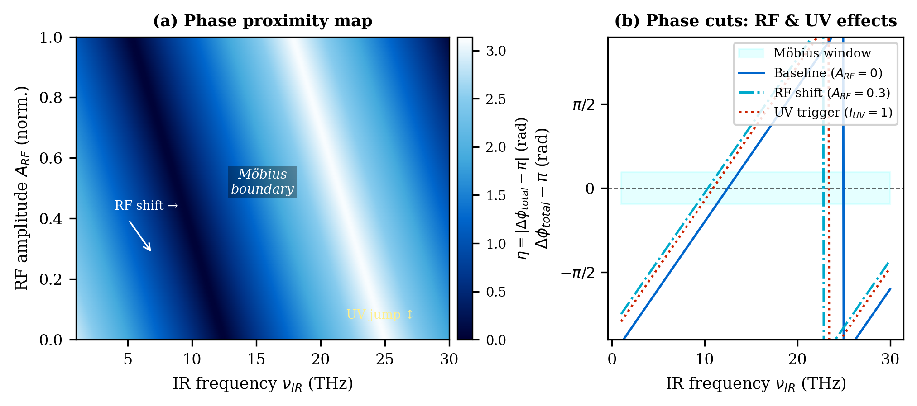
FIG. 1. Multi-frequency phase coupling map. (a) Heatmap of the Möbius proximity parameter η = |Δϕtotal − π| as a function of IR frequency and RF amplitude. Dark ridges indicate the Möbius phase boundary. (b) Line cuts demonstrating continuous RF phase shifting and discontinuous UV-triggered phase jumps. Coupling parameters: α = 1.8, β = 0.55, L = 12 μm.
B. Phase state diagram
Figure 2 presents the phase state diagram in the (ARF, IUV) plane at fixed νir = 10 THz. Three distinct regions emerge: a Normal phase (Δϕ ≠ π, wave propagation unperturbed), the Möbius state (Δϕ ≈ π, topological phase inversion active), and a Transition zone dominated by UV-induced bistability. The diagram reveals complementary control roles: RF enables smooth, analog tuning of the phase boundary (horizontal axis), while UV drives abrupt, digital switching between phases (vertical axis) (2,3). This hybrid analog–digital controllability is a key advantage over physically fixed Möbius structures.
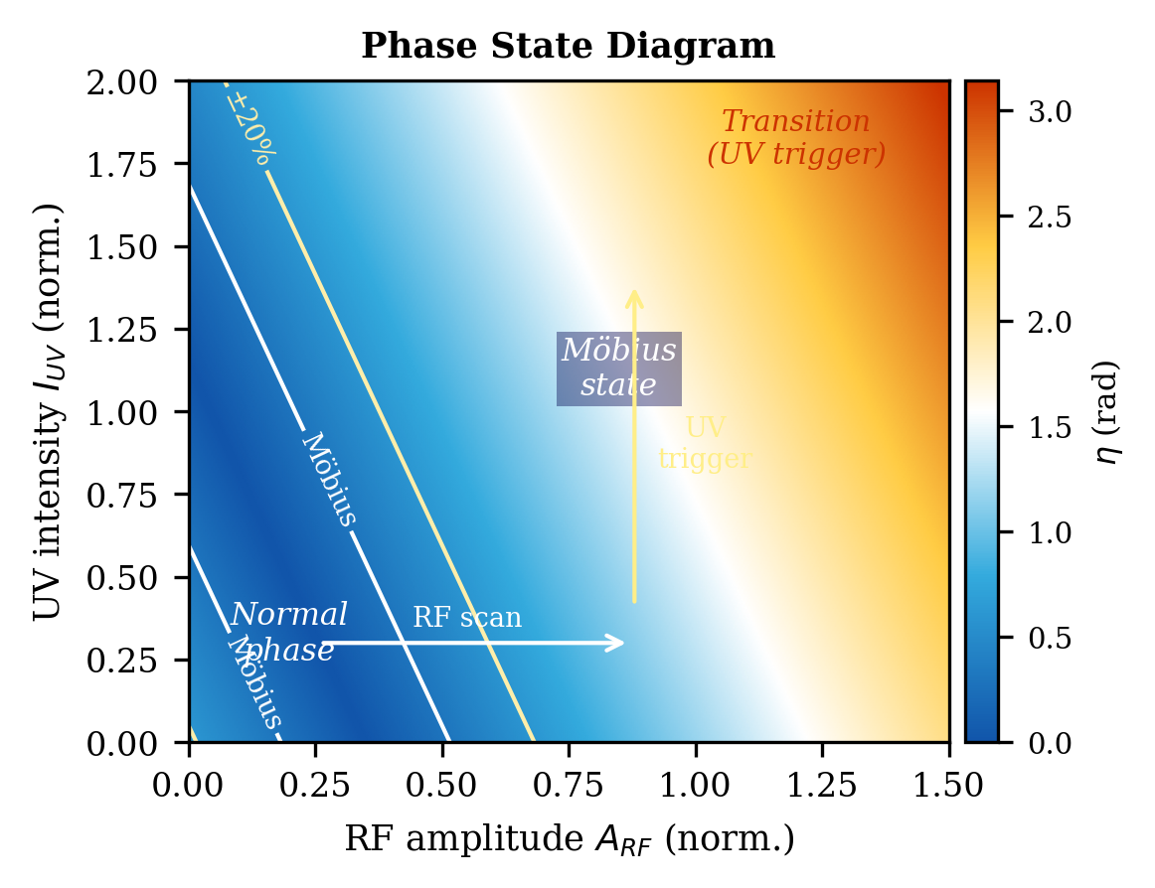
FIG. 2. Phase state diagram in the (ARF, IUV) parameter plane at νir = 10 THz. Möbius state (dark region), Normal phase, and UV-triggered Transition zone are labeled. White contours mark the Möbius boundary (η < 0.3 rad) and ±20% envelope.
C. Topological XOR gate
The most striking consequence of the effective Möbius state is the emergence of XOR logic from purely linear wave interference plus a topological phase flip (4). Two phase-encoded inputs φA, φB ∈ {0, π} are launched into the serpentine waveguide. Under normal interference, identical inputs produce constructive output (AND behavior). When the Möbius condition holds, however, the closed-loop π inversion flips the output for identical inputs, yielding the truth table shown in Fig. 3(b):
Out = sgn[cos(φA + φB + ΔϕM)], ΔϕM = π. (2)
This implements XOR without any conventional nonlinear element. The RF field globally stabilizes the Möbius condition during gate operation, while UV pulses toggle the gate between XOR and non-XOR modes on sub-nanosecond timescales (1,2,4). Figure 3(a) schematically depicts the serpentine waveguide, the RF background field, the UV trigger, and the phase-flip point (Δϕ = π) within the loop.
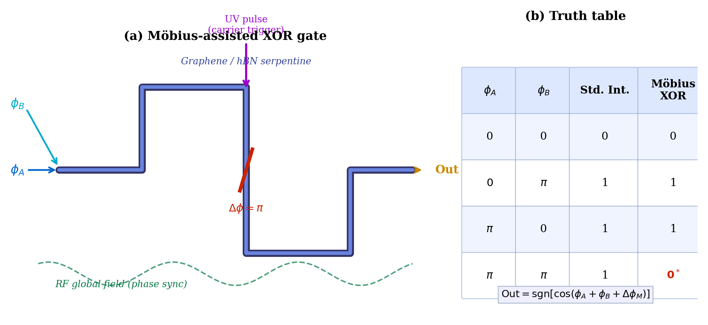
FIG. 3. (a) Schematic of the Möbius-assisted XOR gate. Two phase-encoded inputs (φA, φB) propagate through a graphene/hBN serpentine waveguide. The RF field (dashed green) provides global phase synchronization; a UV pulse (purple arrow) triggers carrier switching at the phase-flip locus (Δϕ = π, red). (b) Truth table confirming XOR behavior under the Möbius condition.
IV. DISCUSSION
The frequency-layered architecture introduced here treats IR/THz, RF, and UV not as competing channels but as physically distinct control planes: local propagation (IR), global synchronization (RF), and nonlinear triggering (UV). This contrasts sharply with conventional single-band photonic devices and enables a qualitatively new form of phase engineering. RF coherence—by virtue of its long wavelength—naturally enforces uniformity across the entire structure, analogous to a global brain wave synchronizing local synaptic events (1,13). UV excitation, conversely, is intrinsically local and ultrafast, enabling state switching on carrier relaxation timescales (~100 fs) (2,3,11). Together these modes cover ten orders of magnitude in frequency (RF at ~10^8 Hz; UV at ~10^{15} Hz), yet cooperate coherently through the single phase equation (1).
The effective Möbius state is distinct from a geometrically fabricated Möbius strip: it lacks true single-surface topology, but reproduces the hallmark phenomenology—π phase inversion per closed traverse—with the crucial advantage of dynamic controllability. The phase boundary can be steered over a continuous range by RF amplitude or discrete UV pulses, enabling both analog (RF) and digital (UV) reconfiguration (5). Fabrication complexity is dramatically reduced compared to three-dimensional Möbius nanostructures (14). The serpentine geometry is fully compatible with standard graphene lithography (9,15).
In the context of neuromorphic computing (6,7), the IR/THz channel plays the role of local synaptic computation, RF acts as a global oscillatory field analogous to neural synchrony, and UV provides the nonlinear threshold switching characteristic of biological memristive synapses (16). The XOR gate demonstrated here is a proof-of-concept for topological logic operations enabled by this multi-frequency Möbius platform.
V. CONCLUSION
We have shown that an effective Möbius topological phase state is achievable in planar graphene–hBN serpentine waveguides through multi-frequency phase engineering. RF irradiation provides continuous global phase control and Möbius state stabilization (1), while UV pulses drive abrupt, nonlinear carrier-mediated phase transitions (2,3). The resulting effective Möbius state realizes topological XOR logic (4) and is characterized by a rich phase diagram with controllable Normal, Möbius, and Transition regions (5). This multi-frequency Möbius framework, requiring no physical topological fabrication, offers a practical and highly reconfigurable route to topological phase computing and opens new directions in wave-based neuromorphic architectures (6,7).
ACKNOWLEDGMENTS
The author declares no conflicts of interest. No external funding was received for this study.
DATA AVAILABILITY
The data and code used to generate the figures in this manuscript are available from the corresponding author upon reasonable request.
REFERENCES
1. S. Manipatruni, D. E. Nikonov, and I. A. Young, "Beyond CMOS computing with spin and polarization," Nat. Phys. 14, 338 (2018). [RF global phase synchronization in spintronic networks.]
2. F. Bonaccorso, Z. Sun, T. Hasan, and A. C. Ferrari, "Graphene photonics and optoelectronics," Nat. Photon. 4, 611 (2010). [Ultrafast carrier dynamics in graphene under UV excitation.]
3. P. A. George, J. Strait, J. Dawlaty, S. Shivaraman, M. Chandrashekhar, F. Rana, and M. G. Spencer, "Ultrafast optical-pump terahertz-probe spectroscopy of the carrier relaxation and recombination dynamics in epitaxial graphene," Nano Lett. 8, 4248 (2008). [Sub-ps UV-induced carrier switching in graphene.]
4. D. A. B. Miller, "Are optical transistors the logical elements for computers?," Nat. Photon. 4, 3 (2010). [Wave-interference logic and XOR operations.]
5. L. Lu, J. D. Joannopoulos, and M. Soljacic, "Topological photonics," Nat. Photon. 8, 821 (2014). [Topological phase diagrams in photonic systems.]
6. J. Torrejon, M. Riou, F. A. Araujo, S. Tsunegi, G. Khalsa, D. Querlioz, P. Bortolotti, V. Cros, K. Yakushiji, A. Fukushima, H. Kubota, S. Yuasa, M. D. Stiles, and J. Grollier, "Neuromorphic computing with nanoscale spintronic oscillators," Nature 547, 428 (2017).
7. G. Tanaka, T. Yamane, J. B. Heroux, R. Nakane, N. Kanazawa, S. Takeda, H. Numata, D. Nakano, and A. Hirose, "Recent advances in physical reservoir computing: A review," Neural Netw. 115, 100 (2019).
8. M. Z. Hasan and C. L. Kane, "Colloquium: Topological insulators," Rev. Mod. Phys. 82, 3045 (2010). [Topological phase invariants and π phase inversion.]
9. A. N. Grigorenko, M. Polini, and K. S. Novoselov, "Graphene plasmonics," Nat. Photon. 6, 749 (2012). [Graphene plasmon dispersion in THz–mid-IR range.]
10. S. Dai, Z. Fei, Q. Ma, A. S. Rodin, M. Wagner, A. S. McLeod, M. K. Liu, W. Gannett, W. Regan, K. Watanabe, T. Taniguchi, M. Thiemens, G. Dominguez, A. H. Castro Neto, A. Zettl, F. Keilmann, P. Jarillo-Herrero, M. M. Fogler, and D. N. Basov, "Tunable phonon polaritons in atomically thin van der Waals crystals of boron nitride," Science 343, 1125 (2014).
11. C.-F. Chen, C.-H. Park, B. W. Boudouris, J. Horng, B. Geng, C. Girit, A. Zettl, M. F. Crommie, R. A. Segalman, S. G. Louie, and F. Wang, "Controlling inelastic light scattering quantum pathways in graphene," Nature 471, 617 (2011). [UV-excited nonlinear optical response in graphene.]
12. A. Vakil and N. Engheta, "Transformation optics using graphene," Science 332, 1291 (2011). [Electrostatic gating of graphene plasmons; RF bias analogy.]
13. G. Buzsáki and A. Draguhn, "Neuronal oscillations in cortical networks," Science 304, 1926 (2004). [Global neural synchrony; analogy to RF phase locking.]
14. Y. Ran, Y. Zhang, and A. Vishwanath, "One-dimensional topologically protected modes in topological insulators with lattice dislocations," Nat. Phys. 5, 298 (2009). [Challenges in topological nanostructure fabrication.]
15. K. S. Novoselov, A. K. Geim, S. V. Morozov, D. Jiang, M. I. Katsnelson, I. V. Grigorieva, S. V. Dubonos, and A. A. Firsov, "Two-dimensional gas of massless Dirac fermions in graphene," Nature 438, 197 (2005).
16. D. B. Strukov, G. S. Snider, D. R. Stewart, and R. S. Williams, "The missing memristor found," Nature 453, 80 (2008). [Memristive switching; UV-analogue threshold behavior.]

